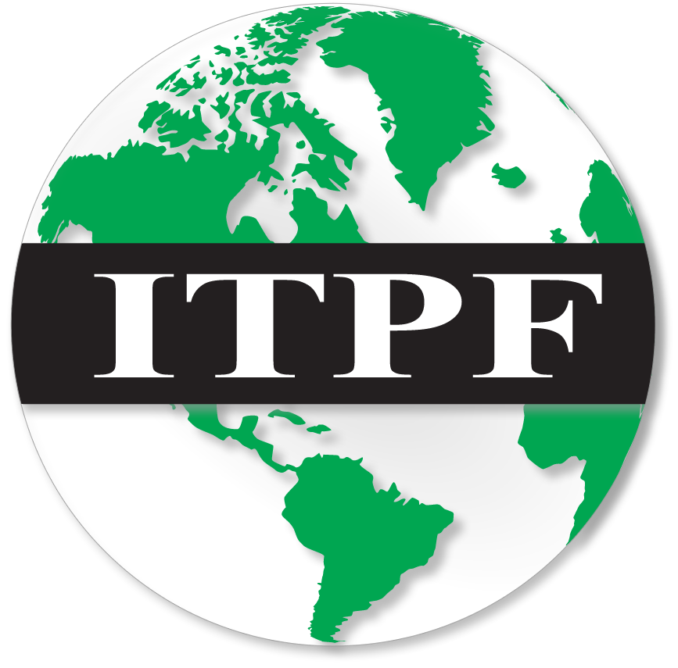
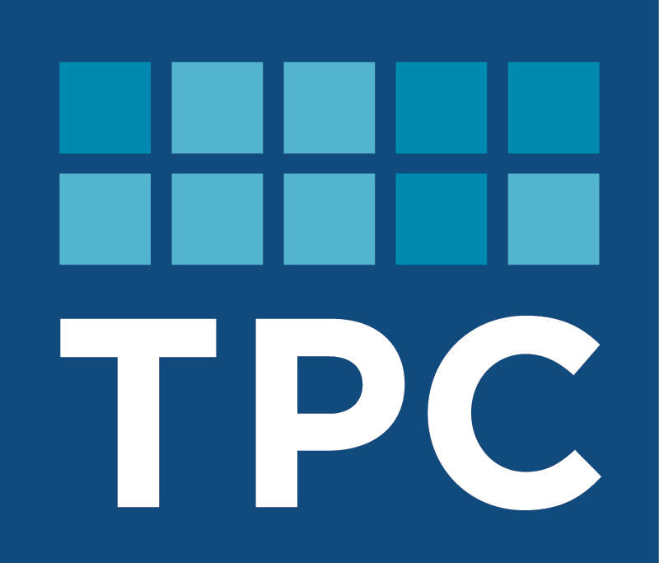

Corporate Inversions and Tax Policy

Featuring Keynote Remarks by Senator Orrin Hatch

Friday, January 23rd, 2015, 8:50 AM – 1:15 PM

The Brookings Institution, Falk Auditorium, 1775 Massachusetts Avenue NW, Washington, DC 20036
Corporate inversions, which change the tax home of a multinational corporation by merging it with a foreign company that then becomes the parent of the multinational group, received considerable attention in 2014, including from the IRS, which in September released a notice describing regulations the government intends to issue to reduce the tax benefits of future inversion transactions. Corporate inversions elicit strong reactions: some call U.S. companies involved in these transactions “unpatriotic,” while others view them as symptomatic of an out-of-step U.S. corporate tax system, with its high rate and worldwide reach that differs from the territorial taxes widely used by other countries. These inversions are also not unique to the U.S, with firms in the United Kingdom and elsewhere also using them during periods when their foreign incomes were subject to high rates of domestic taxation.

On Friday, January 23rd, the Urban-Brookings Tax Policy Center and the International Tax Policy Forum will co-host a conference examining the history, causes, and consequences of corporate inversions, the policy response in the United Kingdom, and what actions the U.S. should take. Experts from a variety of backgrounds will share their perspectives, and Senator Orrin Hatch will give keynote remarks at the close of the event.

8:30 AM: Registration
8:50 AM: Introductory Remarks
William Gale  Co-Director, Urban-Brookings Tax Policy Center | John Samuels  Chairman, International Tax Policy Forum
9:00 AM: The Inversion Experience in the United States and the United Kingdom
Eric Toder (moderator)  Co-Director, Urban-Brookings Tax Policy Center | Mike Williams  Director Business and International Tax, U.K Treasury
Paul Oosterhuis
Partner, Skadden, Arps, Slate, Meagher & Flom LLP
10:15 AM: Incentives to Invert and the Market for Foreign Takeovers
James R. Hines, Jr. (moderator)  L. Hart Wright Collegiate Professor of Law, Michigan Law | Mihir A. Desai (commenter)  Mizuho Financial Group Professor of Law, Harvard Business School; and Professor of Law, Harvard Law School
Andrew Bird
Assistant Professor of Accounting, Tepper School of
Business, Carnegie Mellon University

11:00 AM: Break
11:15 AM: Policy Responses to Corporate Inversions
Michael J. Graetz (moderator)  Columbia Alumni Professor of Tax Law,  Columbia Law School | Edward Kleinbard  Ivadelle and Theodore Johnson Professor of Law and Business, University of Southern California Gould School of Law
Michael Devereux  Director, Oxford University Centre for Business  Taxation; Professor of Business Taxation, Saïd  Business School; and Professorial Fellow, Oriel College | Stephen E. Shay  Professor of Practice, Harvard Law School
James R. Hines, Jr.
L. Hart Wright Collegiate Professor of Law,
Michigan Law
12:15 PM: Luncheon
12:30 PM: Luncheon Address
Senator Orrin Hatch
Chairman, Senate Committee on Finance

To register, please visit
http://connect.brookings.edu/register-to-attend-corporate-inversions-tax-policy
or contact the Brookings Office of Communications
at 202-797-6105 or events@brookings.edu.

